MODULE 4 – INTRODUCTION TO DBMS

LAB EXERCISES

19. Rollback and Commit Savepoint
Lab 1.
Perform a transaction where you create a savepoint, insert record, then rollback to the savepoint.
Ans.
1. START TRANSACTION;

SAVEPOINT sp1;

INSERT INTO courses (course_name, course_duration) VALUES ('Machine Learning', '3 year');

ROLLBACK TO sp1;

COMMIT;

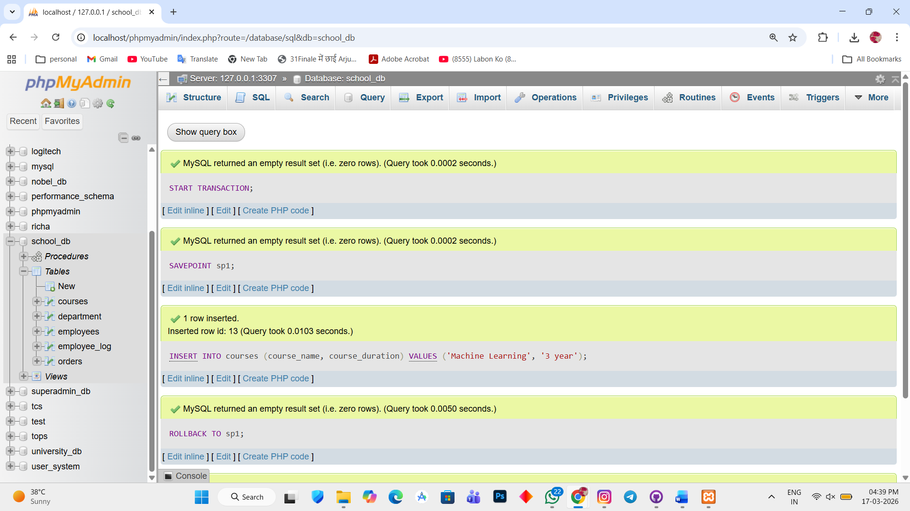

Lab 2.
Commit part of a transaction after using a savepoint and then rollback the remaining changes.
Ans.
1. START TRANSACTION;

INSERT INTO courses (course_name, course_duration) VALUES ('Data Analytics', '2 year');

SAVEPOINT sp2;

INSERT INTO courses (course_name, course_duration) VALUES ('Blockchain', '1 year');

ROLLBACK TO sp2;

COMMIT;

